- Reflection and Congruence

1. Given that A’ (3, -3) is the image of A (-1, -5) under a reflection. Find the equation of the mirror line in the form of 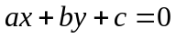 (4 mks)
2. Three planes A, B and C leave an airport P simultaneously at 9.30a.m. Plane A flies on
a bearing of 070º from P at a speed of 400km/h. Plane B flies on a bearing of 290ºat a
speed of 500km/h. Plane C flies on a bearing of 162º from P at a speed of 300km/h.
(Use scale drawing for this question)
(a) Show by scale drawing, the relative positions of the 3planes A, B and C three hours
after leaving airport P. (Use scale 1cm represents 200km)
(b) After 3 hours, B turns and head straight to the current position of A at the same
speed it had. Determine the scale drawing , the time it takes to reach this point, to
the nearest minute
(c) Determine the bearing and distance of B from C after the first 3 hours of flight after
leaving P
- Rotation
1. Triangle PQR has vertices P(3,2), Q(-1,1) and R(-3,-1).
(a) Draw PQR on the grid provided. (1mk)
(b) Under a rotation the vertices of P¹Q¹R¹ are P¹(1,4), Q¹(2,0) and R¹(4,-1). Find the centre and angle of rotation using points P and Q. (4mks)
(c) Triangle PQR is enlarged with scale factor 3 centre O(0,0) to give triangle P²Q²R². Draw triangle P²Q²R² and state its co-ordinates. (2mks)
(d) Triangle P¹Q¹R¹ undergoes reflection in line y = -x to give triangle P³Q³R³. draw P³Q³R³ and state its coordinates. (3mks)
2. The figure below shows part of a diagram of rotation symmetry order 3 about a point O. Complete the diagram. (3mks)
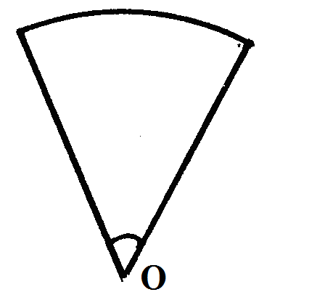
3. In the figure below, triangle A^{I}B^{I}C^{I} is the image of triangle ABC under a rotation, centre O.

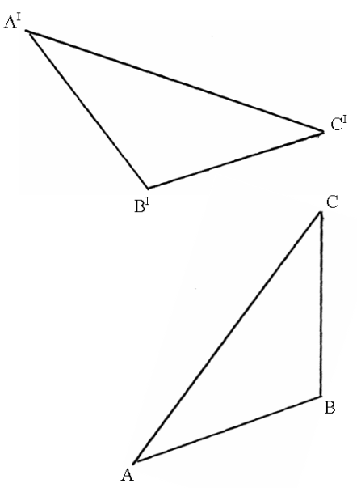

By construction, find and label the centre O of the rotation.
Hence, determine the angle of the rotation. (3mks)
4. The ratio of the lengths of the corresponding sides of two similar rectangular water
tanks is 3: 5. The volume of the smaller tank is 8.1m³. Calculate the volume of the
larger tank

